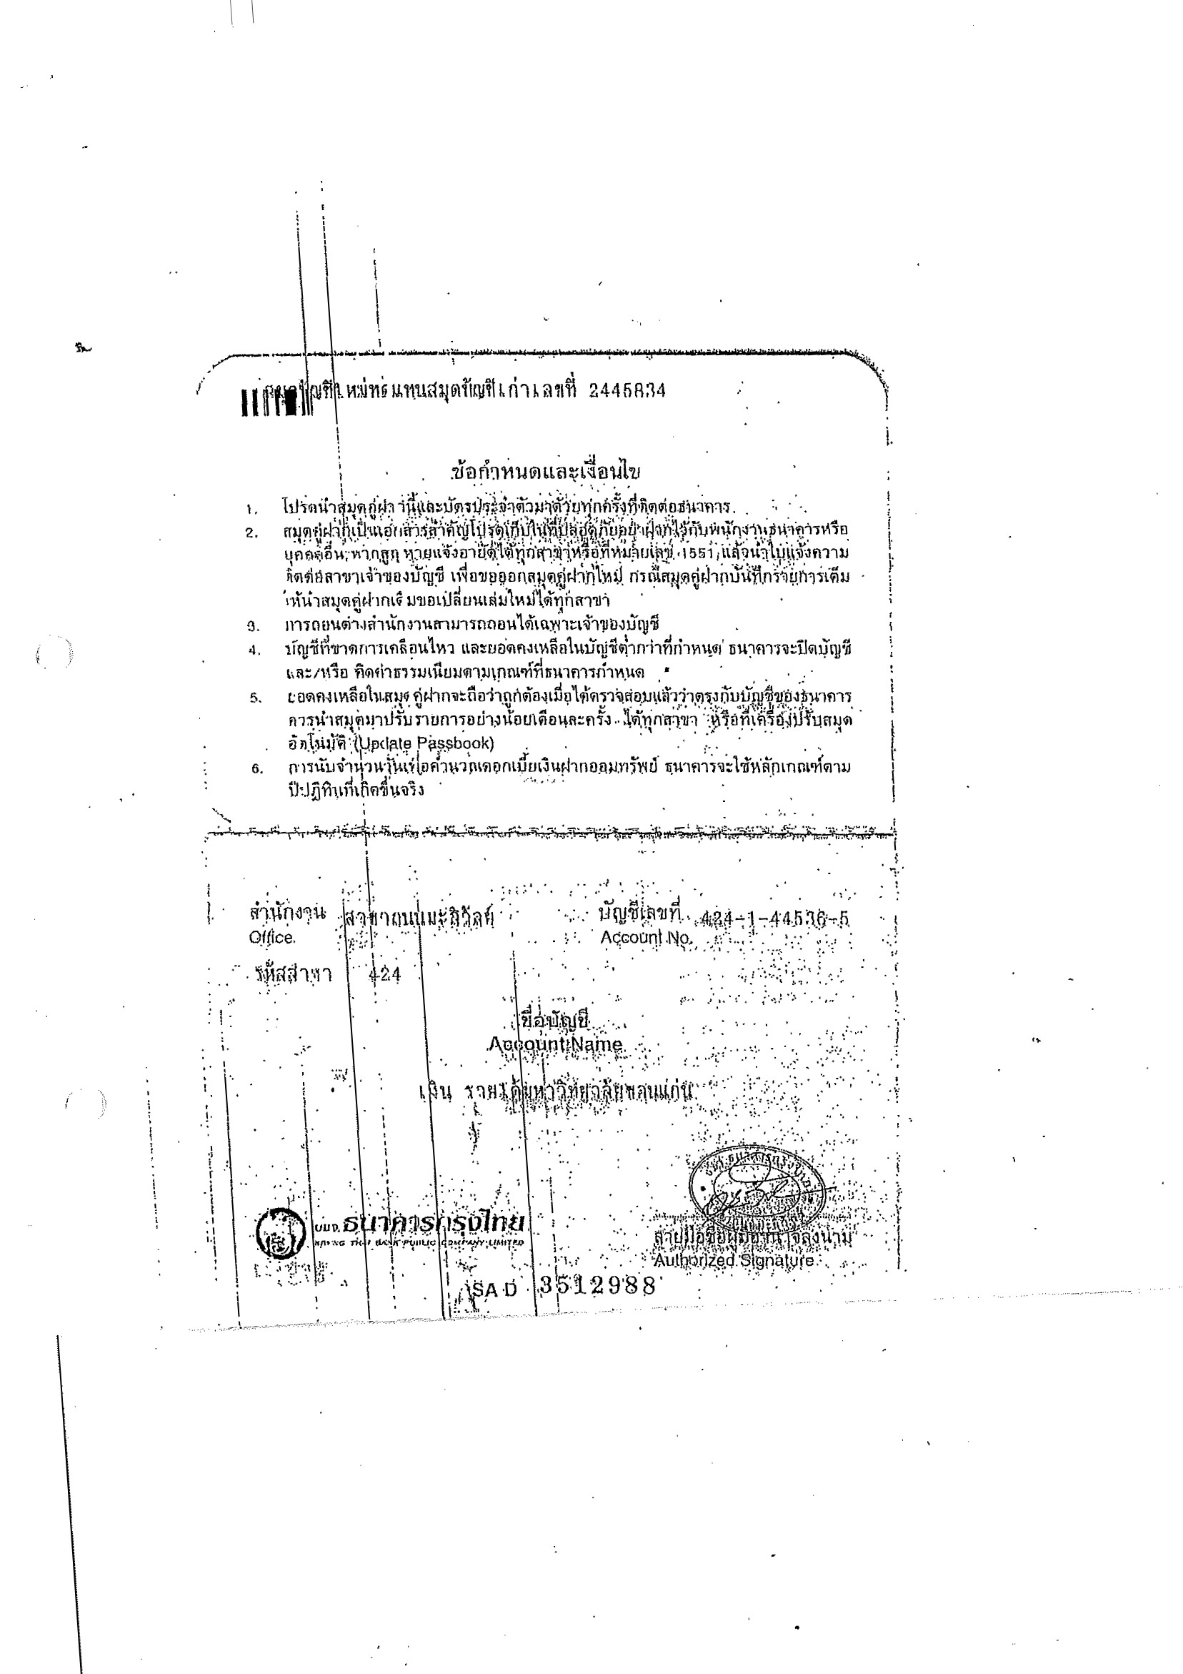
Bank account of the beneficiary organisation
Name and Address of beneficiary:
Khon Kaen University
123 Mittrapap Road, Nai-Muang, Muang District, Khon Kaen 40002, Thailand

Phone: +66 (0)43 202-059
Fax: +66 (0)43 202-498
Taxno.:TH994000391528
E-Mail: ora@kku.ac.th

Bank Name: Krung Thai Bank Public Company Limited
Branch : Maliwal Road Branch
Branch code : 424
Bank Address: 116/8 Maliwal Road, Moo 16, Nai„Muang, Maung district, Khon Kaen, Thailand 40000
Account Number: 424-1-44536-5
Account Name : Khon Kaen University Incomes
Account Type : Saving Account
SWIFT Codes: I<RTHTHBK

For the Beneficiary
The legal represenatative
Assoc. Prof. Charnchai Panthongviriyakul, M.D.
President

Signature & stamp
Done in Khon Kaen, Thailand
Date :

